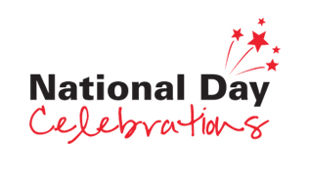
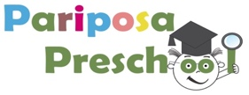

21st July 2017

Dear Parents,

With National Day around the corner, we would like to invite you to come in and celebrate this special occasion with us! Our school is blessed with such a myriad of nationalities and we have had such an exciting time during our Term 3 theme on ‘Our World’ learning about the different cultures. Thus, we thought it would be fantastic to have all of Parioposa’s family gather together and celebrate this country we now live in.

How do you celebrate your nation’s birthday?

Imagine a fusion bazaar where children can visit different booths to find out more about how the different countries celebrate their nation’s birthday. Imagine each booth showcasing special food, costumes, games, art & craft, and anything interesting about your country… Exciting isn’t it? But we need your support to make this possible!

Date: 8th August 2017
Time: 9:30am – 12:30pm
Venue: Pariposa Preschool

If you are gung-ho and would like to set up a booth, fill in the form attached and do approach Ms Ezan or Ms Dinali personally should you have any queries.
If not, you are more than welcomed to come and simply join us for the festivities, experiencing the wonderful family we have here at Pariposa and its culture.

Forms are to be submitted by 28th July 2017, Friday.

Hope to hear from you soon!

Warmest Regards,
Pariposa Team

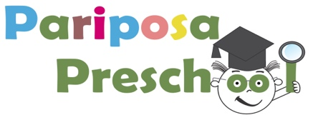

Consent Form

Name of Parent: ___________________

Name of Child: ____________________

Please tick:

I would like to set up a booth.

Country: _____________________

I am not setting up a booth, but I would like to join in for the celebrations.

No. Adults: _______________ No. of Children: _________________

My child and I are not attending.

________________________ _________________________
(Name of Parent/Guardian) (Signature/Date)

Booth setup:

Things provided for you by Pariposa:
- Table and Chairs
- Craft Materials to decorate your booth (Assorted papers, paint, markers..)

A brief description of your booth:

*Food prepared should not contain nuts, pork, or beef.

